WiCa USB cable and ZigBee module driver installation manual

Windows will not properly detect a connected WiCa board through the USB cable or the ZigBee device. Therefore, please follow the following steps to solve this communication problem. Note: this installation procedure only has to be done once.

1. Connect the WiCa board to your computer through the USB cable.

2. Windows will detect new hardware and prompts what to do. Click that window away with the option to do nothing now and hence installing no driver.

3. Go to the Device Manager, right click on the found, but not yet installed USB Serial Port device marked with an exclamation point and choose to update the driver.

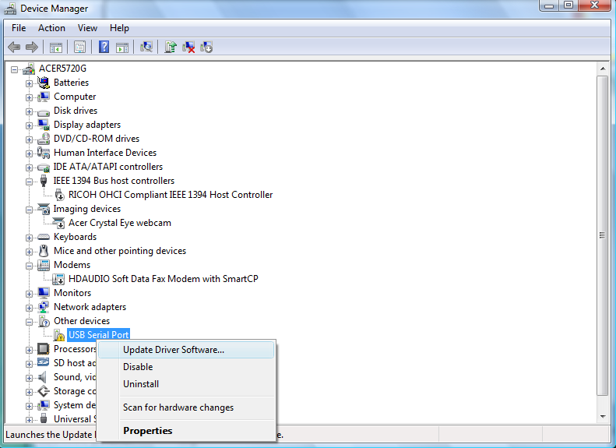

4. If Windows prompts to connect to Windows Update for searching the right driver, choose not to do this.

5. Choose to manually select a location where the driver is located, not to do it automatically.

6. Select the driver location to be the “WiCa fdti driver” map

7. If Windows comes with a message that the driver is not digitally signed, ignore this and continue with the installation.

8. Now, the WiCa USB serial port driver must be installed and visible in the Device Manager without exclamation point. Right click this driver, and choose “Properties”.

9. In the “Port settings” tab, make sure the parameters are set up like the following:

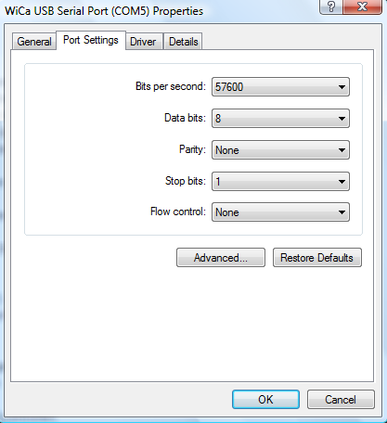

10. Make sure the COM-port (in the example COM5, but it may vary) of the WiCa USB Serial Port is not in use by any other driver. This can be checked in the
“Ports (COM & LPT)” device map in the Device Manager.

11. Also, the mapped COM-port may only lay in the range of COM1..COM9 and may not be higher. If this is not the case, choose the “Advanced” option to change the mapped COM-port to a valid, unused port.

12. We are now done with the installation of this driver. Remember the mapped COM-port, because this port must be entered in the WiCaEnv program.

13. For the USB ZigBee module, follow the same procedure as described.

